Bias and Variance
Regression:
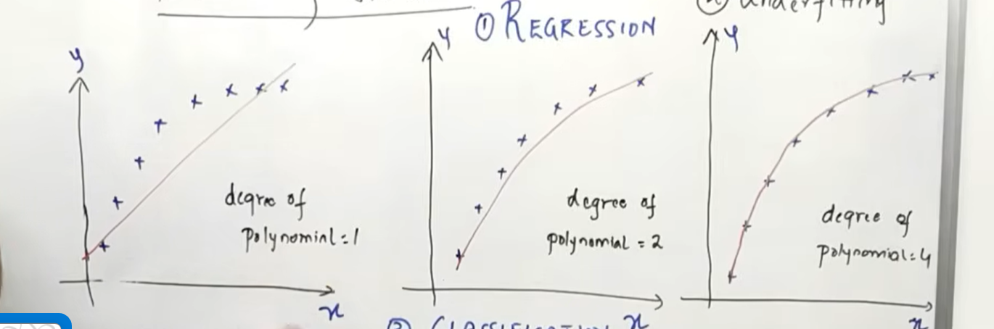
For polynomial 1 we have the r^2 will have more, it is underfitted the training data the accuracy is low and test data accuracy is also low, high bias , high variance
For polynomial 2 there fore it should be selected , because it has low bias and low variance.
For polynomial 4 the model is over fitted training data the accuracy is high but in test data the accuracy is high, low bias , high variance

Training data – bias
Testing data – variance
Classification:
